User Management :

- Sudo su (user super )

2.Sudo adduser reddy
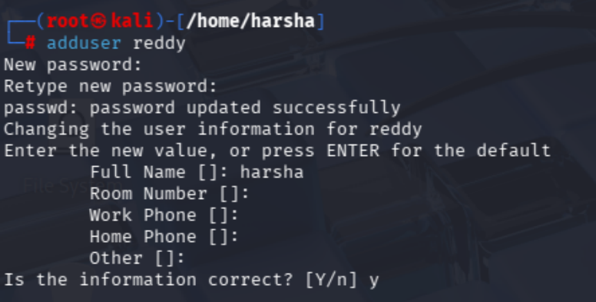

3.id reddy
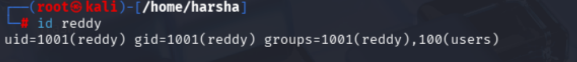

4.groupadd securityteam
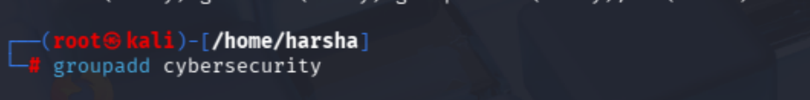

5.usermod -aG reddy cybersecurity (adding user in group)

6.groups reddy

7.chage -l reddy ( checking reddy passwords details)
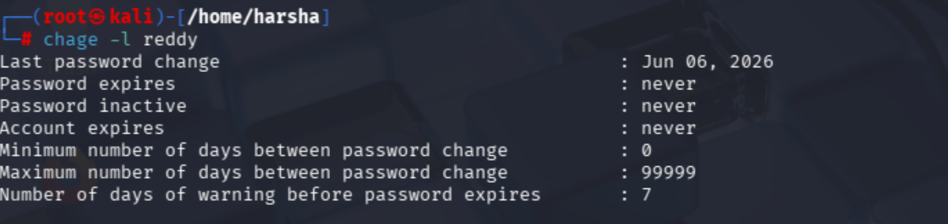

8.chage -E 2027-01-01 reddy (seting account expires )
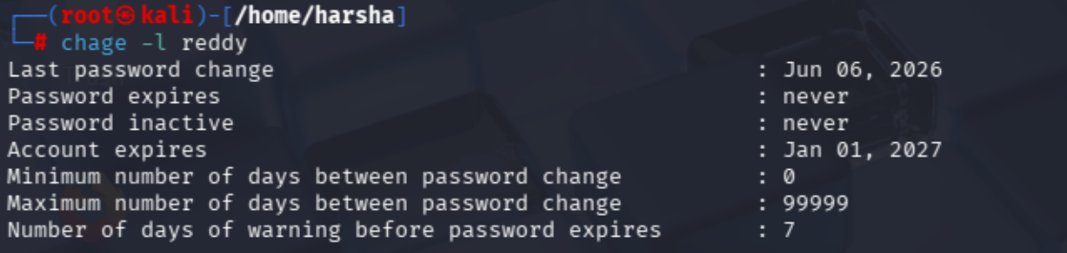
9.chage -M 90 reddy (setting password expires days )
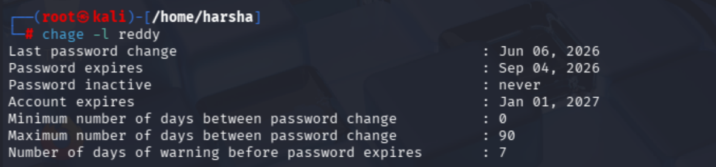

10.passwd reddy (force reset password for user )
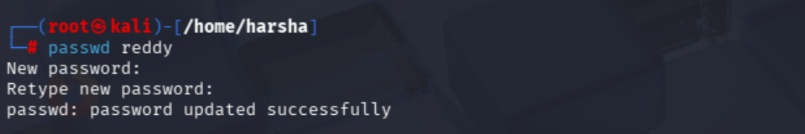

11.last reddy ( checking logs )
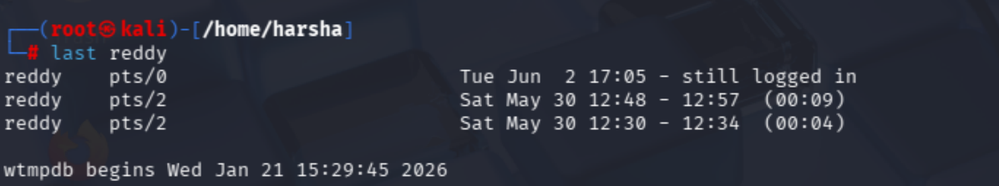

12. passwd -u reddy(lock user)

13.passwd -l reddy (unlock user)
14. usermod -l newname reddy (change username)

15. 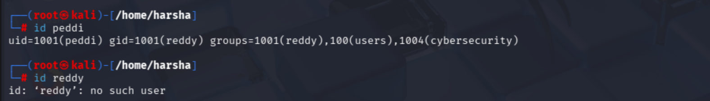

16.userdel -r peddi
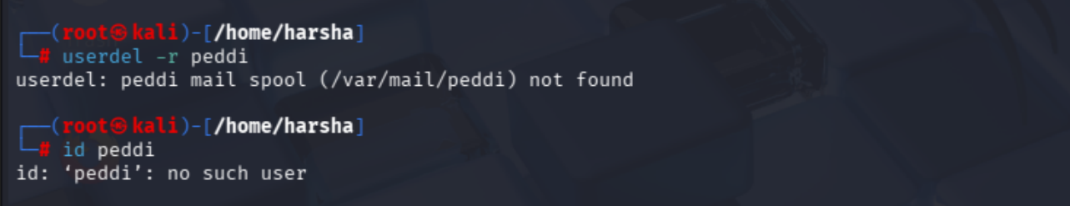
17.cat /etc/passwd
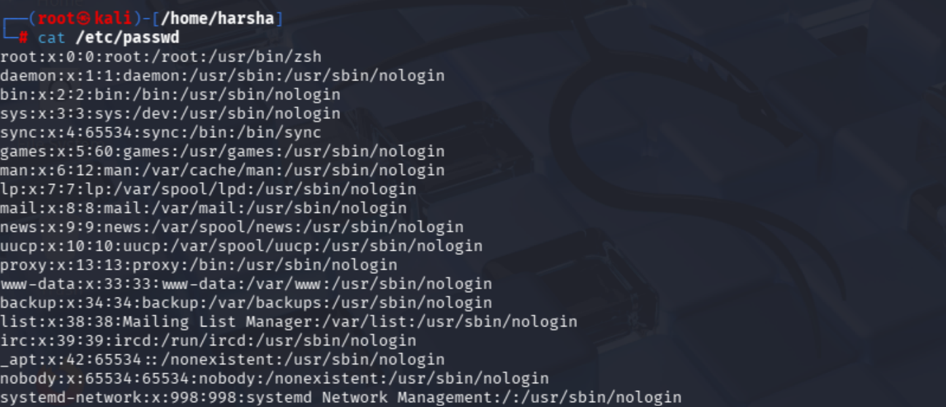

18.whoiam
